certificate of participation
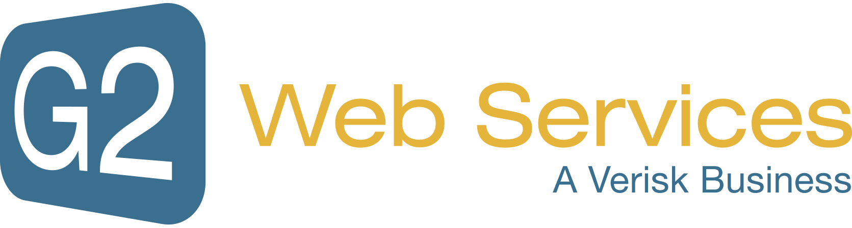
This certificate is presented to

«Name»
For attending this 1-hour course on

Alternative Payment Methods:
The Good, The Bad and The Ugly
CAMS Credits: 1 | Presented By: Jane Hennessy, Head of External Alliances, G2  On This Day: June 11, 2018

